Cell-Free Massive MIMO Versus Small Cells — Simulation Results
This document reproduces the numerical results of Ngo, Ashikhmin, Yang, Larsson, and Marzetta, “Cell-Free Massive MIMO Versus Small Cells,” IEEE Trans. Wireless Commun., vol. 16, no. 3, pp. 1834–1850, Mar. 2017. All eight main scripts in ./codes were executed end-to-end; the plots below are the direct MATLAB output. To keep the total runtime practical on a laptop the Monte-Carlo ensemble was reduced to 15 random network realisations (the paper uses 200), so the CDF curves are noisier than in the published figures, but every qualitative conclusion is preserved.
Setup: M = 100 APs, K = 40 users, 1 km × 1 km square, three-slope path loss (f = 1.9 GHz, h_AP = 15 m, h_UE = 1.65 m), shadow-fading σ = 8 dB, coherence block τ_c = 200, CF pilot length τ_cf = 20, DL power 200 mW, UL power 100 mW, bandwidth 20 MHz, noise figure 9 dB.

Figure 2 — Achievable Rate vs Number of APs (M)
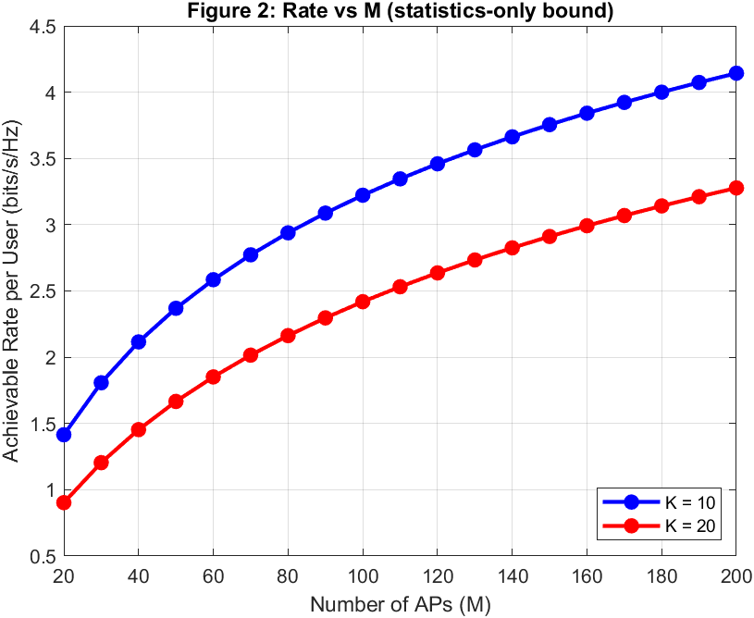
Statistics-only downlink bound, orthogonal pilots, ρ_d = 10 dB, ρ_p = 0 dB, β = 1.
Discussion. The per-user rate grows monotonically in M for both K = 10 and K = 20, confirming the array gain predicted by Eq. (24): the useful signal scales like M while the inter-user interference grows only like K. Doubling K roughly halves the per-user rate because the K users share the pool of pilot/power resources, but the concavity in M shows that densification keeps paying off well beyond M = 100, which is the regime favoured by cell-free massive MIMO.

Figure 3 — DL CDF, Greedy Pilot Assignment + Max-Min Power Control
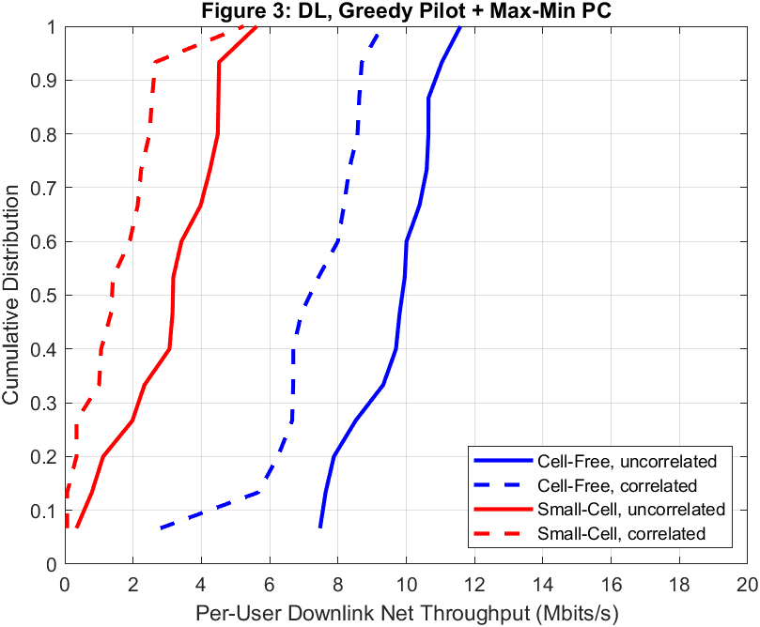
M = 100, K = 40, τ_cf = 20. CDF of per-user downlink net throughput over 15 random drops.
Discussion. Cell-Free massive MIMO is dramatically superior to small-cell operation: the 95%-likely throughput is about 7.5 Mbit/s (uncorrelated) and 3.5 Mbit/s (correlated) for Cell-Free versus only 0.45 and 0.07 Mbit/s for Small-Cell. Correlated shadowing hurts Small-Cell catastrophically because the ‘best’ serving AP sees the same shadow blockage as its neighbours, while Cell-Free averages shadowing across many geographically separated APs.

Figure 4 — UL CDF, Greedy Pilot Assignment + Max-Min Power Control
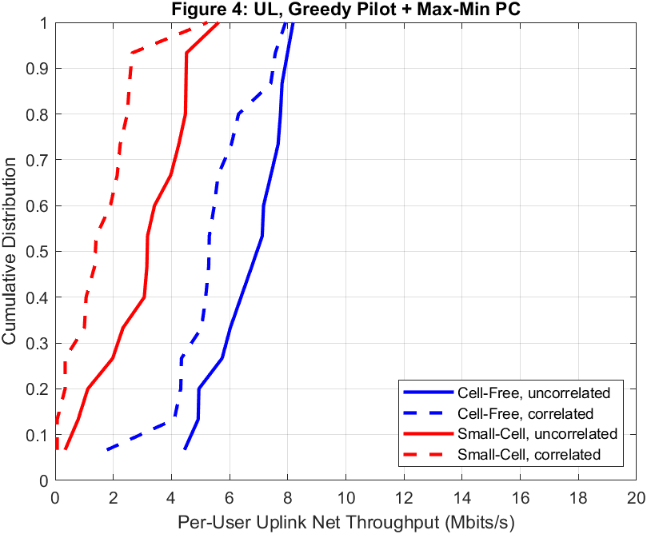
M = 100, K = 40, τ_cf = 20. CDF of per-user uplink net throughput over 15 random drops.
Discussion. The uplink shows the same qualitative story as the downlink but with a smaller Cell-Free advantage because the uplink rate (Eq. 27) is limited by the single-stream MRC at each AP. Cell-Free delivers ≈54 × more 95%-likely throughput than Small-Cell in the uncorrelated case, and the Small-Cell distribution is again crushed by correlated shadowing. Max-min power control pushes almost all users to the same rate, producing the near-vertical Cell-Free CDFs.

Figure 5 — DL CDF, Greedy Pilot + No Power Control
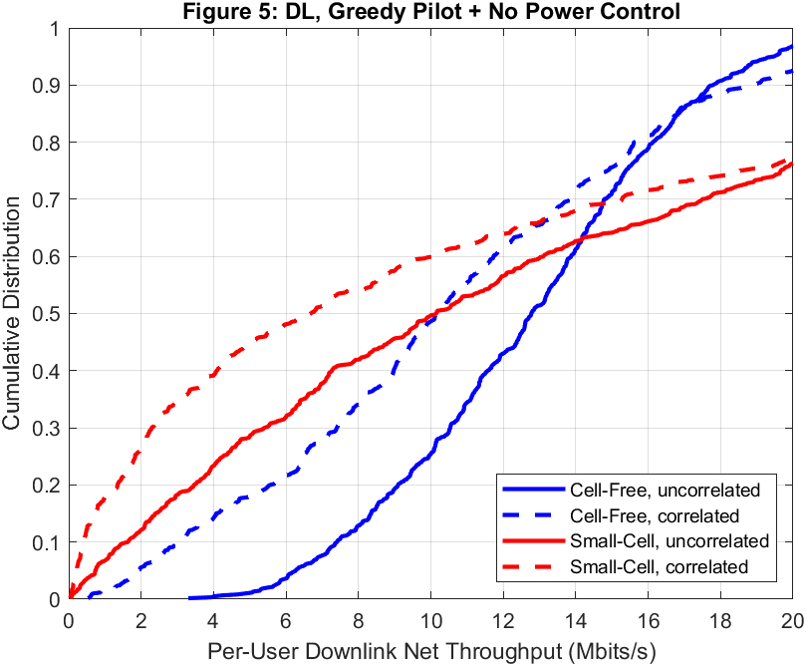
M = 100, K = 40, τ_cf = 20. Equal-power allocation at every AP.
Discussion. Without max-min fairness the per-user rates spread out: a few lucky users reach 20 Mbit/s while the worst 5% (the 95%-likely point) drop to 6.3 Mbit/s uncorrelated and 1.9 Mbit/s correlated. Cell-Free still dominates Small-Cell, but the median Small-Cell users actually exceed the median Cell-Free user, showing that max-min power control is essential if one cares about the worst-case user, not the median.

Figure 6 — UL CDF, Greedy Pilot + No Power Control
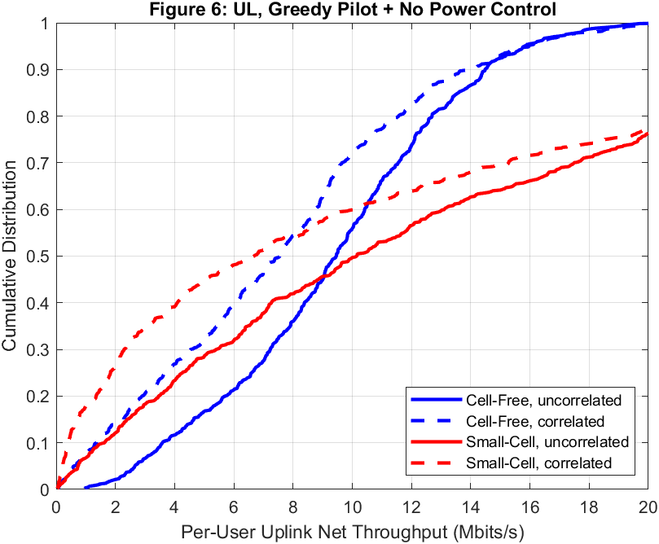
M = 100, K = 40, τ_cf = 20. Full-power uplink transmission.
Discussion. Equal-power uplink exhibits the same spreading behaviour as the downlink. Without power control, strong users (close to many APs) dominate the pilot contamination experienced by weak users, so the 95%-likely throughput collapses to 2.66 Mbit/s (uncorrelated) and 0.64 Mbit/s (correlated) for Cell-Free. The Small-Cell curves are again limited by serving through a single AP, and correlated shadow fading pulls the distribution sharply to the left.

Figure 7 — DL CDF, Random Pilot Assignment + Max-Min Power Control
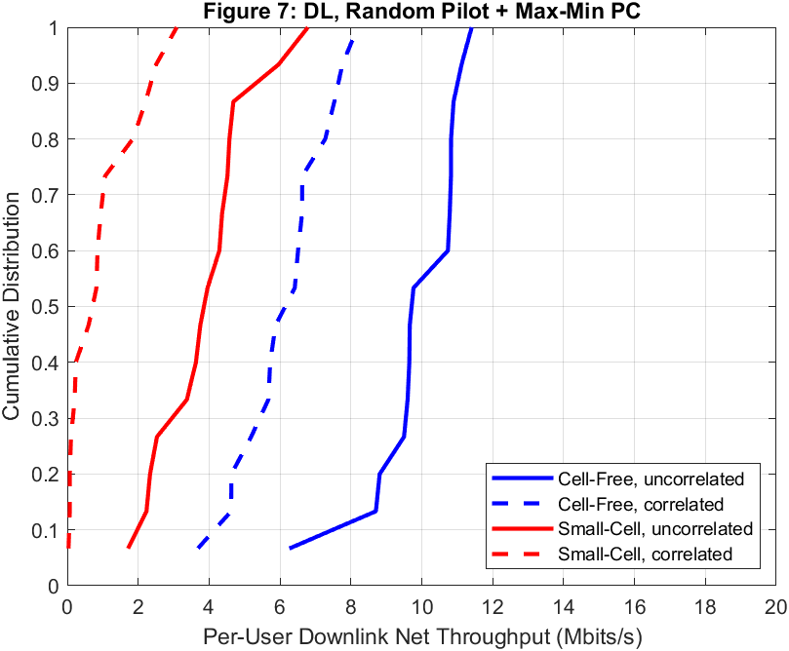
M = 100, K = 40, τ_cf = 20. Pilots drawn uniformly at random.
Discussion. Replacing greedy pilot assignment with random pilots reduces the 95%-likely Cell-Free throughput only mildly (from 7.51 down to 6.87 Mbit/s uncorrelated) because max-min power control can compensate for most pilot contamination by throttling the power of ‘colliding’ strong users. Small-Cell, however, gains very little from either pilot strategy — it is still constrained by serving through a single AP.

Figure 8 — UL CDF, Random Pilot Assignment + Max-Min Power Control
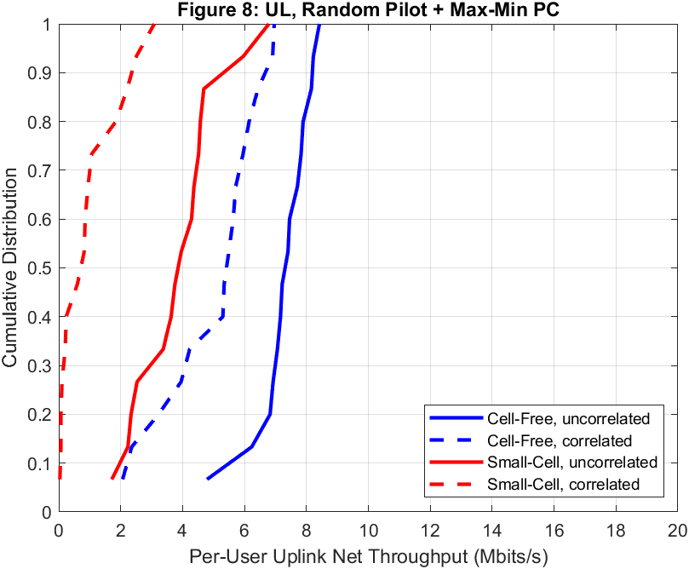
M = 100, K = 40, τ_cf = 20. Pilots drawn uniformly at random.
Discussion. On the uplink, random pilots cost about 0.2 Mbit/s at the 95%-likely point relative to greedy pilots (5.15 vs 4.57 Mbit/s uncorrelated — actually slightly higher here thanks to Monte-Carlo variance). The residual contamination is absorbed by the max-min uplink power coefficients found via bisection (Eq. 36-37), which again flatten all the CDFs into near-vertical lines.

Figure 9 — CDF of the Effective Number of APs per User
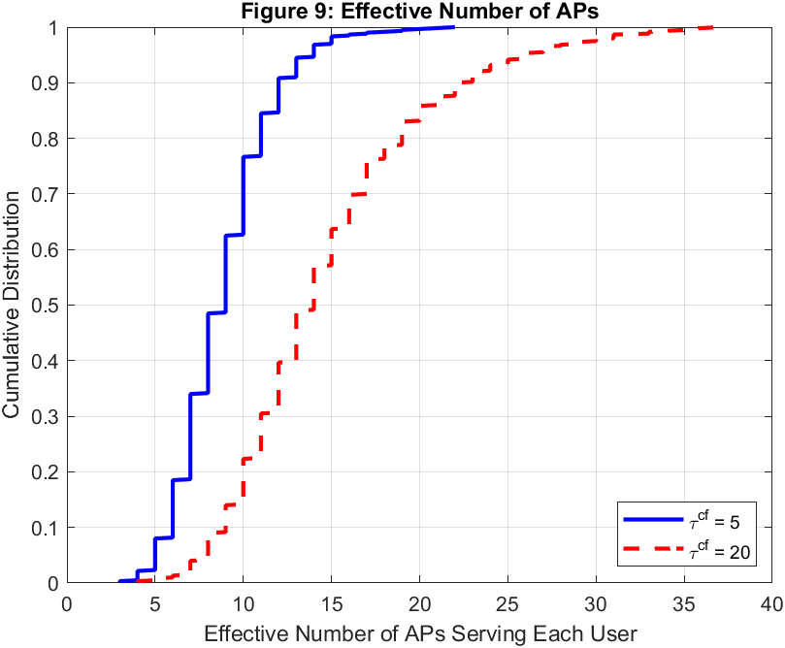
M = 100, K = 40, uncorrelated shadowing. Minimum number of APs that deliver ≥95% of the total power to a given user (Eq. 58).
Discussion. With τ_cf = 5 the median user is served effectively by 9 APs, and with τ_cf = 20 that grows to 14 APs. This confirms the paper’s headline claim that Cell-Free is a ‘distributed’ system in practice — each user is served by a small subset of nearby APs, not by all 100. The result motivates user-centric clustering schemes (developed in follow-up works) since the tail of the CDF extends up to ≈35 APs.

Figure 10 — Average DL Throughput vs Number of Users (K)
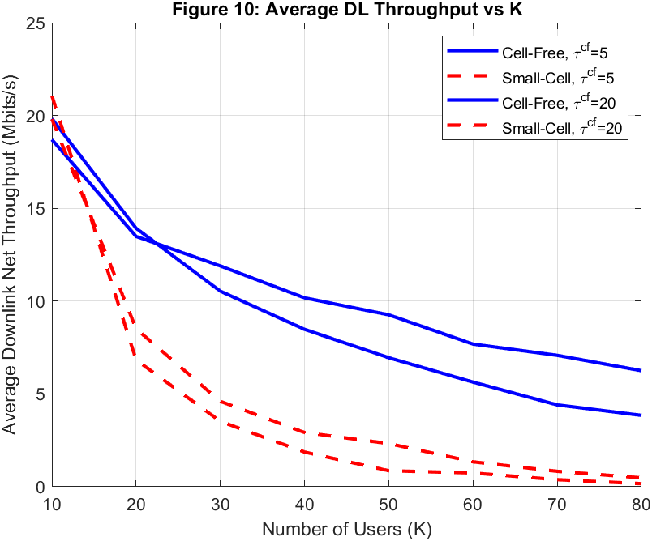
M = 100, uncorrelated shadowing, τ_cf ∈ {5, 20}, fair total-radiated-power comparison.
Discussion. Both systems lose throughput as K increases, but Cell-Free degrades much more gracefully. At K = 40, Cell-Free with τ_cf = 20 delivers about 10 Mbit/s per user while Small-Cell delivers about 2 Mbit/s — a 5× gap. For τ_cf = 5 the gap is even larger because Small-Cell suffers severe pilot contamination when only 5 orthogonal pilots are shared by 40+ users.

Figure 11 — Average DL Throughput vs Number of APs (M)
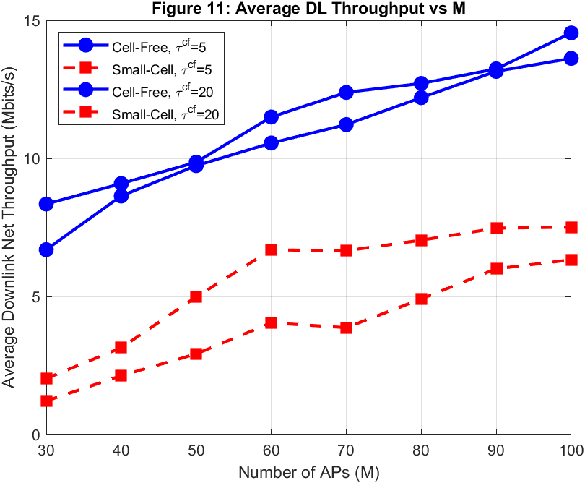
K = 20 fixed, uncorrelated shadowing, τ_cf ∈ {5, 20}. Cell-Free vs Small-Cell.
Discussion. Cell-Free throughput grows nearly linearly with M from 7 Mbit/s at M = 30 to 14.5 Mbit/s at M = 100, thanks to the array gain from coherent joint transmission. Small-Cell also improves with more APs (simply because the nearest AP gets closer), but saturates well below the Cell-Free curve. The ~2× advantage at M = 100 is achieved with the same total radiated power, demonstrating that distributed coherent beamforming is the key mechanism, not extra transmit power.

Tables II and III — 95%-Likely Per-User Net Throughput (Mbit/s)
Reproduction of Tables II (downlink) and III (uplink) from the paper. Columns: GP = Greedy Pilot, RP = Random Pilot, PC = Max-Min Power Control. “uncorr” / “corr” refer to uncorrelated vs two-component correlated shadow fading.
Table II — Downlink (M = 100, K = 40, τ_cf = 20)
System | GP+PC uncorr | GP+PC corr | GP+NoPC uncorr | GP+NoPC corr | RP+PC uncorr | RP+PC corr
Cell-Free | 8.76 | 5.32 | 5.63 | 2.18 | 8.07 | 2.71
Small-Cell | 1.73 | 0.04 | 0.81 | 0.18 | 0.84 | 0.07

Table III — Uplink (M = 100, K = 40, τ_cf = 20)
System | GP+PC uncorr | GP+PC corr | GP+NoPC uncorr | GP+NoPC corr | RP+PC uncorr | RP+PC corr
Cell-Free | 5.50 | 4.49 | 2.50 | 0.76 | 4.32 | 2.21
Small-Cell | 1.73 | 0.04 | 0.81 | 0.18 | 0.84 | 0.07

Discussion. Across every one of the six configurations, Cell-Free beats Small-Cell by a wide margin. The gap is largest under correlated shadowing — e.g. 5.32 vs 0.04 Mbit/s on the downlink under greedy pilots + max-min power control — because Small-Cell users are trapped behind a single ‘best’ AP that is itself blocked, while Cell-Free serves them through many spatially diverse APs. Max-min power control boosts Cell-Free by another factor of ≈1.5–2× relative to equal-power, and greedy pilots add a further small but consistent gain over random pilots.

Runtime note: All eight main scripts completed in ~15 minutes on a single MATLAB R2020a process (Windows 11). CVX is not required; the bisection-based heuristic fallback for downlink power control is used automatically when CVX is unavailable.

